Week 10 Lecture 2

Previous Lecture
- Stack

Today’s Lecture
- Queue

What is a Queue?
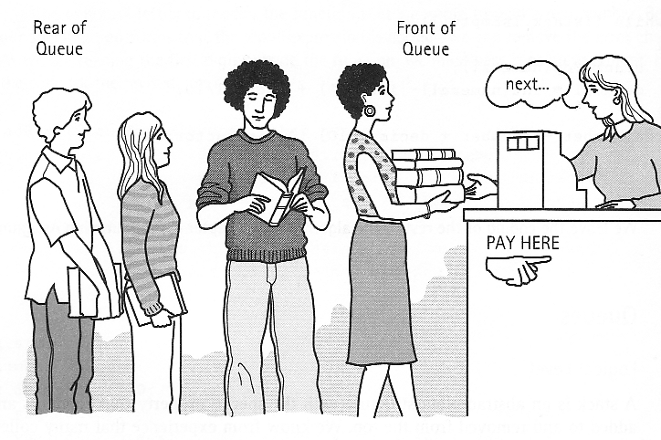
What is a Queue?

- Logical (or ADT) level: A queue is an ordered group of homogeneous items (elements), in which new elements are added at one end (the rear), and elements are removed from the other end (the front).

- A queue is a FIFO “first in, first out” structure.
Queue ADT Operations

- MakeEmpty -- Sets queue to an empty state.
- IsEmpty -- Determines whether the queue is currently empty.
- IsFull -- Determines whether the queue is currently full.
- Enqueue (ItemType newItem) -- Adds newItem to the rear of the queue.

- Dequeue (ItemType& item) -- Removes the element at the front of the queue and returns it in item.
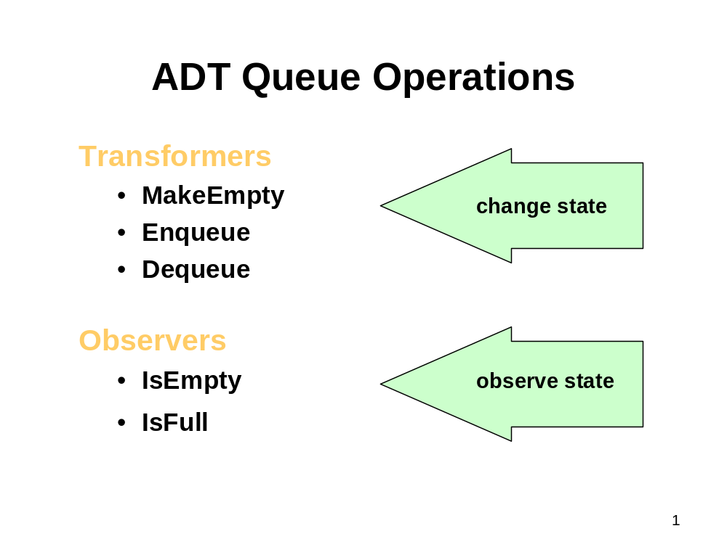
Queue ADT Operations
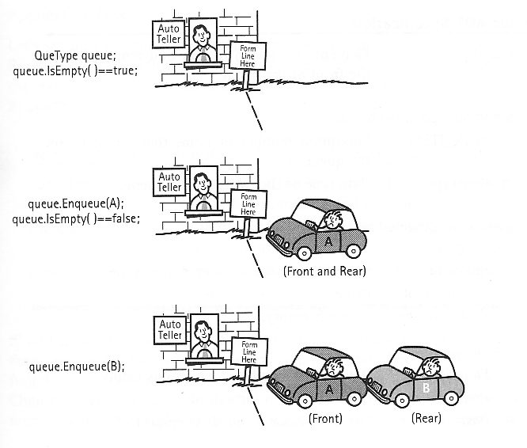
Queue ADT Operations
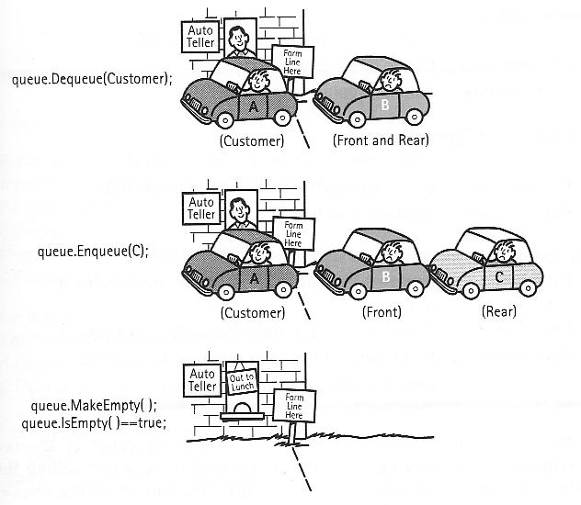
Implementation of Queue Operations

- Stack
- LIFO
- Bottom is fixed
- Top is changing

- Queue
- FIFO
- Rear must be changing because of addition
- Can the front be fixed ?
Implementation of Queue Operations
- Enqueue(A), Enqueue(B), Enqueue(C), Enqueue(D)
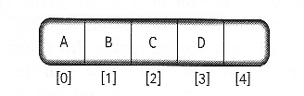
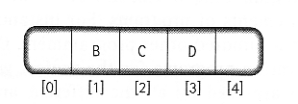
- Dequeue(item)
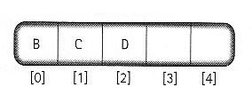
*?
Implementation of Queue Operations

- Enqueue operation the same as Push

- Dequeue operation more complicated than Pop

- MakeEmpty, IsEmpty, and IsFull operations the same as the equivalent stack operations

Another Queue Design

- Let the both ends of queue float in the array
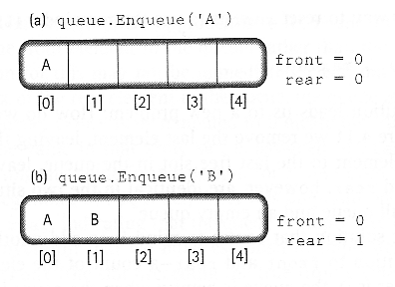
Another Queue Design
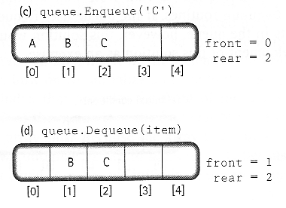
Another Queue Design
- Wrap around

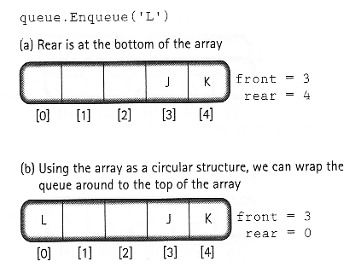
Another Queue Design

- Formula for Wrap-around
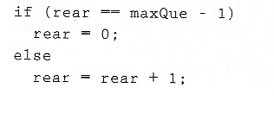

rear = (rear + 1) % maxQue

Another Queue Design

- an empty queue
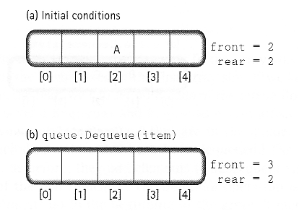
Another Queue Design

- a full queue
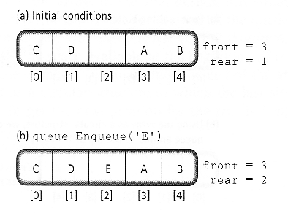
Another Queue Design

- how to distinguish an empty and full queue
- introduce another variable to count number of elements in the queue.

- let front indicate the index of the array slot preceding the front element in the queue. rear still indicates the index of the rear element in the queue.

Another Queue Design

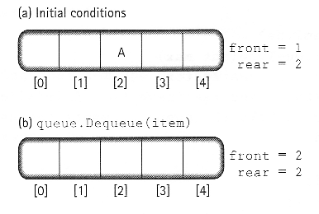
- testing for an empty queue
Another Queue Design

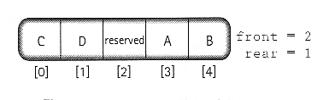
- testing for a full queue

- the element preceding the front of the queue is reserved.
- We initialize front to maxQue – 1 and rear to front, i.e., maxQue – 1. ?
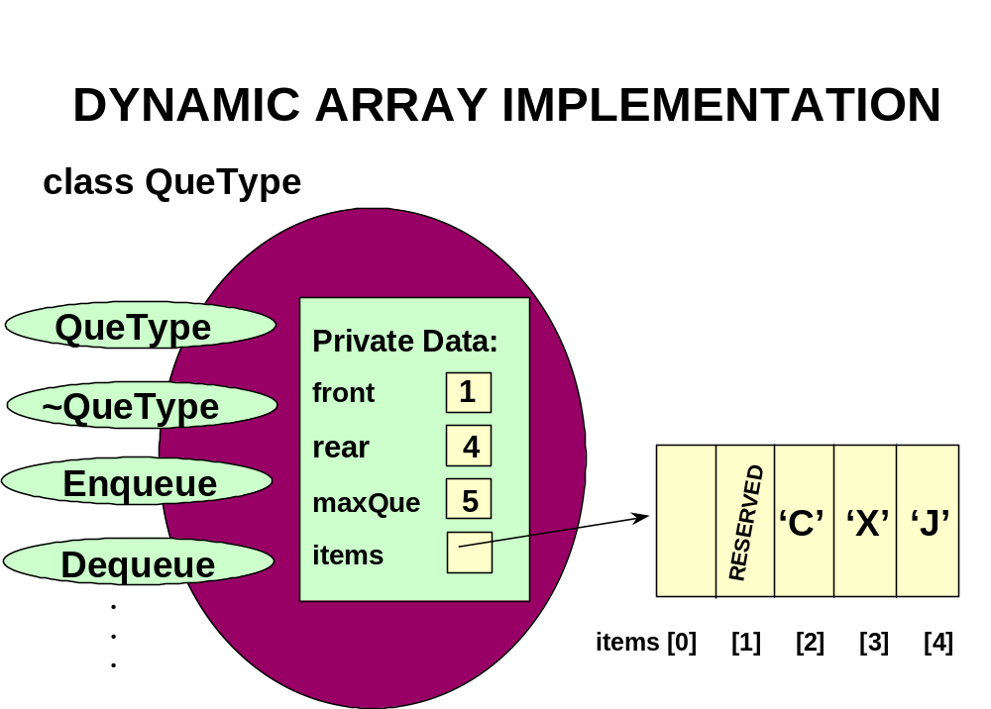
//--------------------------------------------------------
// CLASS TEMPLATE DEFINITION FOR CIRCULAR QUEUE
#include "ItemType.h" // for ItemType
template<class ItemType>
class QueType
{
public:
QueType( );
QueType( int max ); // PARAMETERIZED CONSTRUCTOR
~QueType( ) ; // DESTRUCTOR
. . .
bool IsFull( ) const;
void Enqueue( ItemType item );
void Dequeue( ItemType& item );
private:
int front;
int rear;
int maxQue;
ItemType* items; // DYNAMIC ARRAY IMPLEMENTATION };
//--------------------------------------------------------
// CLASS TEMPLATE DEFINITION FOR CIRCULAR QUEUE cont’d
//--------------------------------------------------------

template<class ItemType>
QueType<ItemType>::QueType( int max ) // PARAMETERIZED
{
maxQue = max + 1;
front = maxQue - 1;
rear = maxQue - 1;
items = new ItemType[maxQue]; // dynamically allocates
}

template<class ItemType>
bool QueType<ItemType>::IsEmpty( )

{
return ( rear == front )
}
//--------------------------------------------------------
// CLASS TEMPLATE DEFINITION FOR CIRCULAR QUEUE cont’d
//--------------------------------------------------------

template<class ItemType>
QueType<ItemType>::~QueType( )
{
delete [ ] items; // deallocates array
}

.
.
.

template<class ItemType>
bool QueType<ItemType>::IsFull( )

{ // WRAP AROUND
return ( (rear + 1) % maxQue == front )
}

//--------------------------------------------------------
// CLASS TEMPLATE DEFINITION FOR CIRCULAR QUEUE cont’d
//--------------------------------------------------------

template<class ItemType>
void QueType<ItemType>::Enqueue( ItemType newItem )
// Post: newItem is at the rear of the queue
{
rear = (rear + 1) % maxQue;
items[rear] = newItem;
}

template<class ItemType>
void QueType<ItemType>::Dequeue( ItemType &newItem )
// Post: The front of the queue has been removed and a copy returned in item
{
front = (front + 1) % maxQue;
newItem = items[front];
}

Today’s Lecture

- Queue

Next Lecture

- Sorting Algorithms

